Feedback

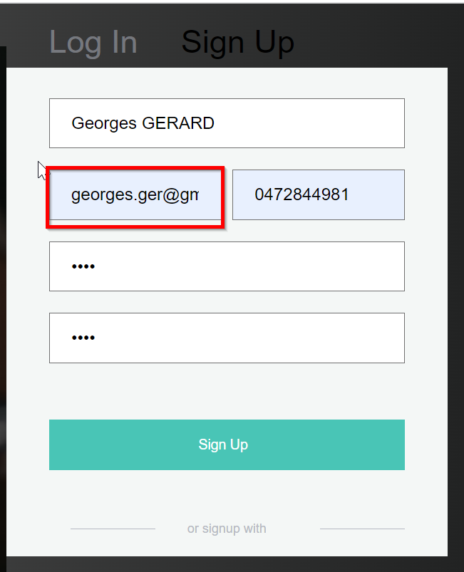

Mail add truncated **=> OK**

Can't sign up (psw too short but no message) + add possibility to show psw **=> no “show password button”**



We should have a default icon **=> Still no default icon**

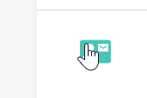

We need "on mouse over" captions on each clickable element

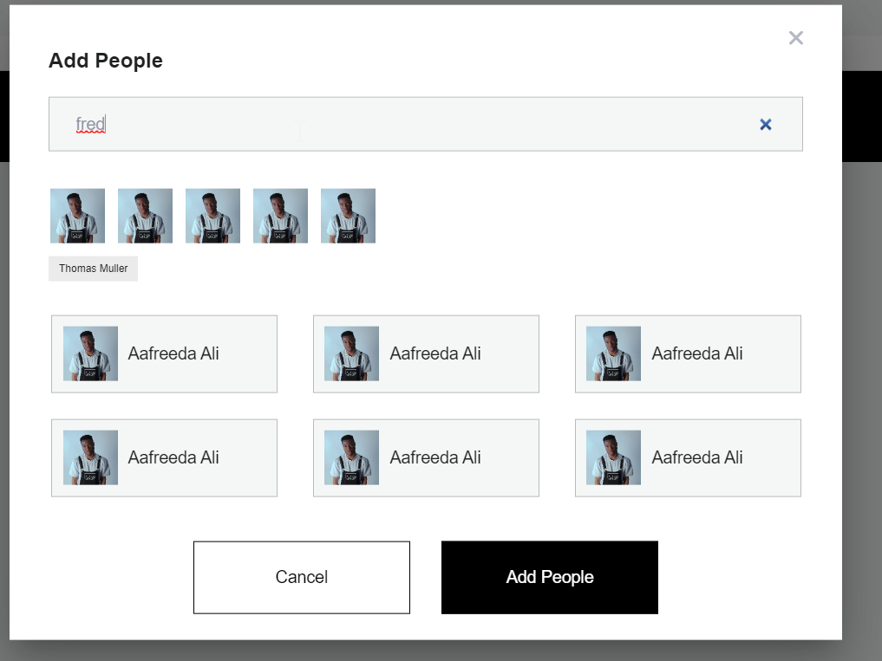

Not working **=> still not working, results are shown or not randomly always with a huge latency ( > 23sec) I suppose the latency is the issue**

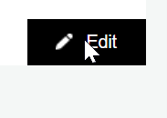

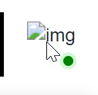

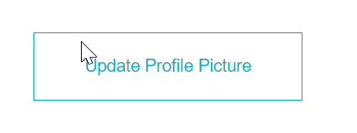

The cursor should change if clickable **=> OK**

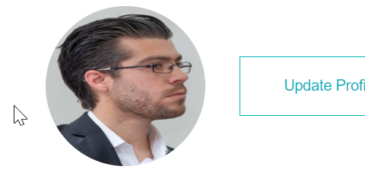

The profile picture is distorted => NOK

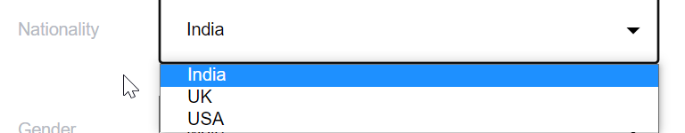

We miss a few things in the dropdownlist **=> NOK**

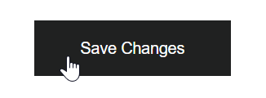

Save does not work **=> work only if every field has been filled, need to have a popup and highlight mandatory fields**

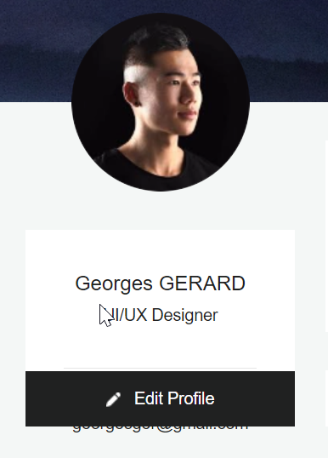

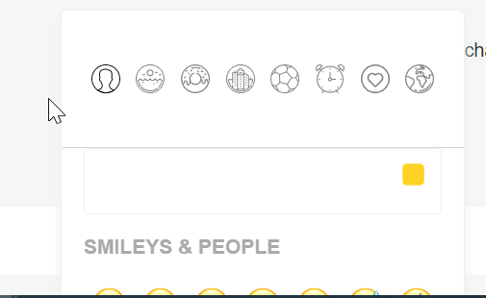

Visibility issues **=> NOK see screenshot hereunder:**



No notification when a message is received

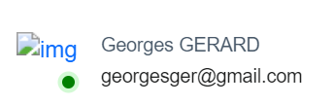

Dots in addresses are removed it should be [georges.ger@gmail.com](mailto:georges.ger@gmail.com)  **=> NOK**

Profile can't be changed

Admin pannel :

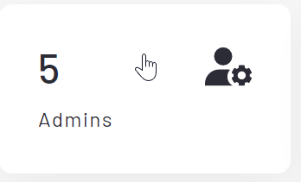

Nothing happens when clicking on admins or users from the dashboard **=> OK**

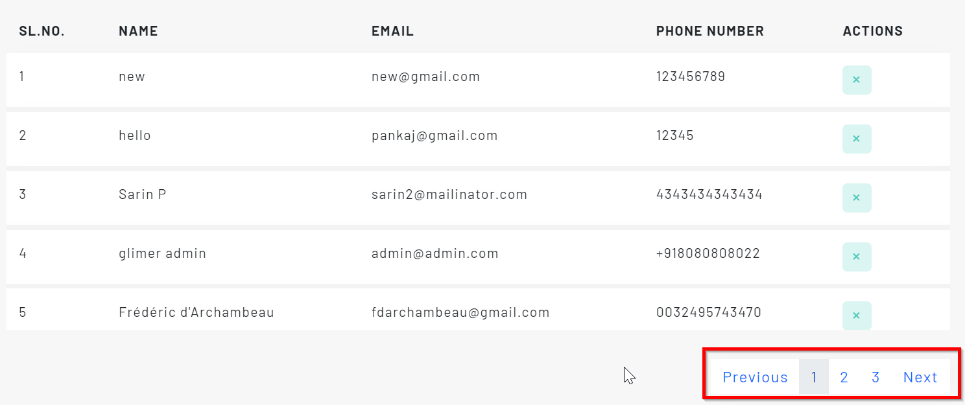

We have only 1 page but hardcoded to 3 pages **=> OK**

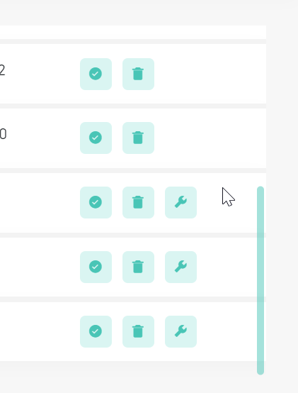

The scrollbar should be visible to notify that some users are not visible without scrolling

* **OK**

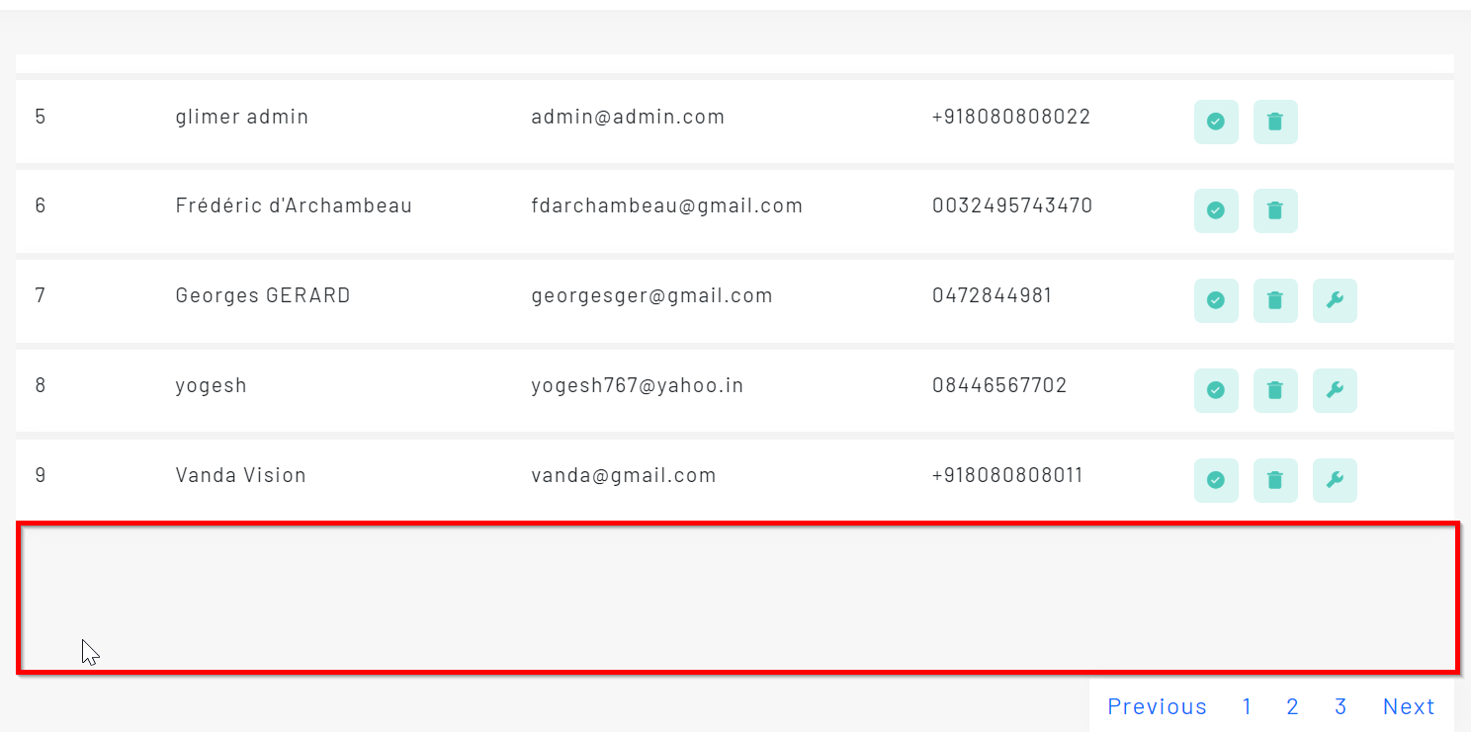

Useless empty space **=> OK**

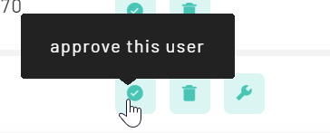

The "approve this user" button should change for approved users to revoke approval or disable user

* **OK**

1. Test On iphone
   1. Test Sign up  
      => OK

The mail address is weird “trackschoolbus”?? The message is not adequate. I should verify my email as well.

The sign up fields might need to be reviewed for the Name and First name.

* 1. The UI size resolution is not adapted to a phone  
     => NOK

* 1. We cannot change the profile. The save button does not work. And there is no option to change the job title.  
     => NOK
  2. We cannot search for a person to talk to on the phone at least.  
     => OK
  3. We cannot see the text when we are typing  
     => NOK

* 1. The pop-up with special menu is not visible  
     => OK

* 1. The pin conversation works but the recent should be stay visible as well   
     => OK
  2. Diagram

     Description automatically generated with medium confidence
  3. General : many things are not working… We don’t know whether it is normal or it is a lack of testing.